

# TCL 20L+

## Type of device: Mobile

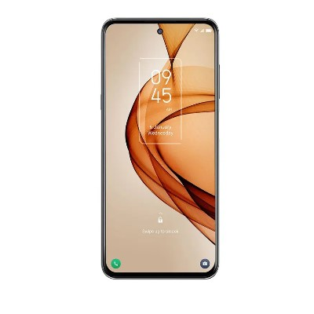

Actual Display Size : 6.67 inches

Button Type : Touchscreen

Operating System : Android

Version Number : Android 11

Network Capability : 3G,4G

Year of Release : 2021

Average Price : $348 as of 27 08 2021

## Accessibility Features:

### Cognitive

* Additional Instructions
* Copy and Paste
* GPS
* Photo Telephone List
* Screen Timeout Disabled
* Simple Instructions
* Simple Reminders
* Simplify Display

Voice Notes

### Hearing Impairment and Deaf

* Allows for sign language communication
* Bluetooth or Wi-Fi
* Closed Captioning
* Front Facing Camera
* Text Messaging/SMS
* Vibrating Alerts - Adjustable
* Video Communications - Two-way

Visual Alerts - Incoming Calls

### Vision

* Battery Alert - Audible
* Bluetooth or Wi-Fi
* Brightness Adjustable
* Dictation / Speech-to-Text
* High Contrast Mode
* Personalised Shortcuts
* Power Cue
* Screen Magnifier
* Screen Reader
* Text Size Adjustable
* Text Style Adjustable
* Voice Control /Personal Assistant

Voiced Menus

### Speech

* Allows for sign language communication
* Bluetooth or Wi-Fi
* Messaging Options - Email
* Messaging Options - IM
* Messaging Options - MMS
* Predictive Text

SMS Personalisation and Reuse

### Physical

* Automatic Answer
* Bluetooth or Wi-Fi
* Dictation / Speech-to-Text
* Gesture Based Navigation
* Headset - plug connected
* Predictive Text
* Speaker-phone option
* Stylus or Prosthetic Device support
* Switch control option
* Voice Control / Personal Assistant
* Voice Recognition for Accessing Features

Voice Recognition for Dialling

## How and where to get it from?

You can buy this phone from [Kogan](https://www.kogan.com/au/buy/mobile-world-tcl-20l-plus-dual-sim-256gb6gb-667-tcl20lpcfg-tcl20lpblk/), [Dick Smith](https://www.dicksmith.com.au/da/buy/mobile-world-tcl-20l-plus-dual-sim-256gb6gb-667-tcl20lpcfg-tcl20lpblk/), [Harvey Norman](https://www.harveynorman.com.au/catalogsearch/result/?q=TCL+20L%2B), and other retailers.

## More information is available on:

[TCL 20L+ Webpage](https://www.tcl.com/au/en/mobile/tcl-20lplus/landing.html)

[TCL 20L+ Specifications Webpage](https://www.tcl.com/au/en/mobile/tcl-20lplus/specification.html)

[TCL 20L+ User Manual (PDF Download)](https://mss.tclcom.com/TCL+20L%2B/TCL+20L%2B_T775H_UM_English.pdf)